NAME-AMAN JAIN
ASSIGNMENT 6 (SHELL SCRIPT)
1).
Script:-

#!/bin/bash
if [ $# -ne 2 ]
then
echo "Usage - $0 x y"
echo " Where x and y are two nos for which I will print sum"
exit 1
fi
echo "Sum of $1 and $2 is `expr $1 + $2`"

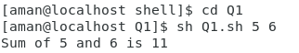
output:-

2).
Script:-
#!/bin/bash
if [ $# -ne 3 ]
then
echo "$0: number1 number2 number3 are not given" >&2
exit 1
fi
n1=$1
n2=$2
n3=$3
if [ $n1 -gt $n2 ] && [ $n1 -gt $n3 ]
then
echo "$n1 is biggest number"
elif [ $n2 -gt $n1 ] && [ $n2 -gt $n3 ]
then
echo "$n2 is biggest number"
elif [ $n3 -gt $n1 ] && [ $n3 -gt $n2 ]
then
echo "$n3 is biggest number"
elif [ $1 -eq $2 ] && [ $1 -eq $3 ] && [ $2 -eq $3 ]
then
echo "All the three numbers are equal"
else
echo "I can not figure out which number is bigger"
fi

output:-
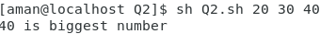

3).
Script:-
#!/bin/bash
myname=amanjain
echo hello $myname

output:-

4).
Script:-
#!/bin/bash
i=5
while test $i != 0
do
printf "$i,"
i=`expr $i - 1`
done

5).
Script:-
#**************************************************
# Q5.sh
# Created by AMAN JAIN (amanjainmahaveer@gmail.com) on 08/01/19.
# Description: SHELL SCRIPT ASSIGNMENT
# ORGANISATION:EITRA TRAINING RESEARCH CENTER
#**************************************************
#!/bin/bash
i=2
while [ $i -le 8 ]
do
printf "$i "
i=`expr $i + 1`
done

output:-

6).
#**************************************************
# Q6.sh
# Created by AMAN JAIN (amanjainmahaveer@gmail.com) on 08/01/19.
# Description: SHELL SCRIPT ASSIGNMENT
# ORGANISATION:EITRA TRAINING RESEARCH CENTER
#**************************************************
#!/bin/bash
if test $# = 3
then
case $2 in
+) let z=$1+$3;;
-) let z=$1-$3;;
/) let z=$1/$3;;
x|X) let z=$1*$3;;
*) echo Warning - $2 invalied operator, only +,-,x,/ operator allowed
exit;;
esac
echo Answer is $z
fi

output:-
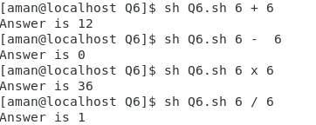

7).
Script:-
#**************************************************
# Q7.sh
# Created by AMAN JAIN (amanjainmahaveer@gmail.com) on 08/01/19.
# Description: SHELL SCRIPT ASSIGNMENT
# ORGANISATION:EITRA TRAINING RESEARCH CENTER
#**************************************************
#!/bin/bash
echo " $LOGNAME "
echo "Current date is `date`"
echo " user is `who i am` "
echo "current directory `pwd`"

Output:-
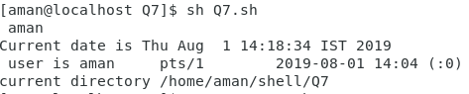

8).#!/bin/bash
temph=`date | cut -c12-13`
dat=`date +"%A %d in %B of %Y (%r)"`

if [ $temph -lt 12 ]
then
mess="Good Morning $LOGNAME, Have nice day!"
fi

if [ $temph -gt 12 -a $temph -le 16 ]
then
mess="Good Afternoon $LOGNAME"
fi

if [ $temph -gt 16 -a $temph -le 18 ]
then
mess="Good Evening $LOGNAME"
else
echo -e "$mess\nThis is $dat"
fi

Output:-
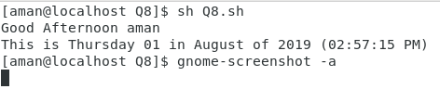

9).
Script:-
#!/bin/bash
seconds=0

echo -n "Enter number of seconds : "
read seconds

hours=$((seconds / 3600))
seconds=$((seconds % 3600))
minutes=$((seconds / 60))
seconds=$((seconds % 60))

echo "$hours:$minutes:$seconds"

output:-
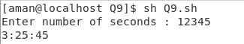

10).
Script:-
#!/bin/bash
if [ $# -ne 1 ]
then
echo "Usage: $0 number"
fi
n=$1
rev=0
sd=0

while [ $n -gt 0 ]
do
sd=`expr $n % 10`
rev=`expr $rev \* 10 + $sd`
n=`expr $n / 10`
done
echo "Reverse number is $rev"

output:-
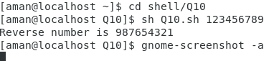

11).
#!/bin/bash
if [ $# -ne 1 ]
then
echo "Usage:$0 number"
fi
n=$1
sum=0
sd=0
while [ $n -gt 0 ]
do
sd=`expr $n % 10`
sum=`expr $sum + $sd`
n=`expr $n / 10`
done
echo "Sum of digit for number is $sum"
Output:-


12).
Script:-
#!/bin/bash
filename=$1
result=`locate -c $filename`
if [ -n $result ]
then
echo " this $result exists "
else
echo "this $filename doesn't exist"
fi

Output:-
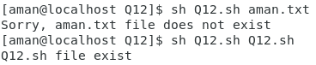

13).
Script:-
#!/bin/bash
cat "$1" > /tmp/file.$$ 2>/tmp/file0.$$

grep "*" /tmp/file.$$ >/tmp/file0.$$

if [ $? -eq 1 ]
then
echo "Required i.e. $1/*"
else
echo "Symbol is Not required"
fi

Output:-
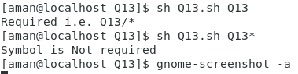

14).
Script:-
#!/bin/bash
if [ $# -eq 0 ]
then
echo "$0:Error command arguments missing!"
echo "Usage: $0 start_line uptoline filename"
echo "Where start_line is line number from which you would like to print file"
echo "uptoline is line number upto which would like to print"
fi
if [ $# -eq 3 ]; then
if [ -e $3 ]; then
tail $3 | head -n$2
else
echo "$0: Error opening file $3"
exit
fi
else
echo "Missing arguments!"
fi

Output:-
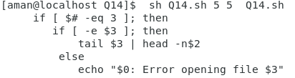

16).
Script:-
#!/bin/bash
let=`date | cut -c12-13`
dat=`date +"%A %d in %B of %Y (%r)"`

if [ $let -lt 12 ]
then
mess="Good Morning $LOGNAME, Have nice day!"
fi

if [ $let -gt 12 -a $let -le 16 ]
then
mess="Good Afternoon $LOGNAME"
fi

if [ $let -gt 16 -a $let -le 18 ]
then
mess="Good Evening $LOGNAME"
fi
echo -e "$mess\nThis is $dat"

Output:-
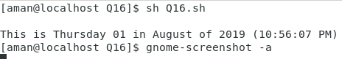

17).
#!/bin/bash
echo -e "\033[1m Hello World"
echo -e "\033[5m Blink"
echo -e "\033[0m Hello World"
echo -e "\033[31m Hello World"
echo -e "\033[32m Hello World"
echo -e "\033[33m Hello World"
echo -e "\033[34m Hello World"
echo -e "\033[35m Hello World"
echo -e "\033[36m Hello World"
echo -e "\033[41m Hello World"
echo -e "\033[42m Hello World"
echo -e "\033[43m Hello World"
echo -e "\033[44m Hello World"
echo -e "\033[45m Hello World"
echo -e "\033[46m Hello World"
echo -e "\033[0m Hello World"

Output:-
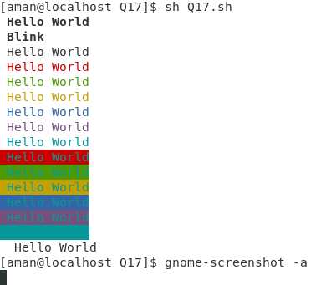

18).
Script:-
#!/bin/bash
while :
do
ti=`date +"%r"`
echo -e -n "\033[7s"
tput cup 0 69
echo -n $ti
echo -e -n "\033[8u"
sleep 1

Output:-
19).Script:-
#!/bin/bash
read -p "What is your first name? " firstname
firstname=${firstname,,}
echo "Hello, ${firstname}."
y="AMAN JAIN"
echo "${y^^}"
y="aman jain"
echo "${y,,}"

Output:-

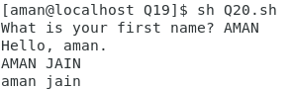

20).
Script:-
#!/bin/bash
nouser=`who | wc -l`
echo -e "User name: $USER (Login name: $LOGNAME)" >> /tmp/info.tmp.01.$$$
echo -e "Current Shell: $SHELL" >> /tmp/info.tmp.01.$$$
echo -e "Home Directory: $HOME" >> /tmp/info.tmp.01.$$$
echo -e "Your O/s Type: $OSTYPE" >> /tmp/info.tmp.01.$$$
echo -e "PATH: $PATH" >> /tmp/info.tmp.01.$$$
echo -e "Current directory: `pwd`" >> /tmp/info.tmp.01.$$$
echo -e "Currently Logged: $nouser user(s)" >> /tmp/info.tmp.01.$$$

if [ -f /etc/redhat-release ]
then
echo -e "OS: `cat /etc/redhat-release`" >> /tmp/info.tmp.01.$$$
fi

if [ -f /etc/shells ]
then
echo -e "Available Shells: " >> /tmp/info.tmp.01.$$$
echo -e "`cat /etc/shells`" >> /tmp/info.tmp.01.$$$
fi

if [ -f /etc/sysconfig/mouse ]
then
echo -e "--------------------------------------------------------------------" >> /tmp/info.tmp.01.$$$
echo -e "Computer Mouse Information: " >> /tmp/info.tmp.01.$$$
echo -e "--------------------------------------------------------------------" >> /tmp/info.tmp.01.$$$
echo -e "`cat /etc/sysconfig/mouse`" >> /tmp/info.tmp.01.$$$
fi
echo -e "--------------------------------------------------------------------" >> /tmp/info.tmp.01.$$$
echo -e "Computer CPU Information:" >> /tmp/info.tmp.01.$$$
echo -e "--------------------------------------------------------------------" >> /tmp/info.tmp.01.$$$
cat /proc/cpuinfo >> /tmp/info.tmp.01.$$$

echo -e "--------------------------------------------------------------------" >> /tmp/info.tmp.01.$$$
echo -e "Computer Memory Information:" >> /tmp/info.tmp.01.$$$
echo -e "--------------------------------------------------------------------" >> /tmp/info.tmp.01.$$$
cat /proc/meminfo >> /tmp/info.tmp.01.$$$

if [ -d /proc/ide/hda ]
then
echo -e "--------------------------------------------------------------------" >> /tmp/info.tmp.01.$$$
echo -e "Hard disk information:" >> /tmp/info.tmp.01.$$$
echo -e "--------------------------------------------------------------------" >> /tmp/info.tmp.01.$$$
echo -e "Model: `cat /proc/ide/hda/model` " >> /tmp/info.tmp.01.$$$
echo -e "Driver: `cat /proc/ide/hda/driver` " >> /tmp/info.tmp.01.$$$
echo -e "Cache size: `cat /proc/ide/hda/cache` " >> /tmp/info.tmp.01.$$$
fi
echo -e "--------------------------------------------------------------------" >> /tmp/info.tmp.01.$$$
echo -e "File System (Mount):" >> /tmp/info.tmp.01.$$$
echo -e "--------------------------------------------------------------------" >> /tmp/info.tmp.01.$$$
cat /proc/mounts >> /tmp/info.tmp.01.$$$

if which dialog > /dev/null
then
dialog --backtitle "Linux Software Diagnostics (LSD) Shell Script Ver.1.0" --title "Press Up/Down Keys to move" --textbox /tmp/info.tmp.01.$$$ 21 70
else
cat /tmp/info.tmp.01.$$$ |more
fi

Output:-
